First Session:

* Philena - Screenshare
  + 3 Design Alternatives
* Tim
  + Problem, Stakeholders, Project Goal, Evaluation & Criteria

Second Session:

* Hannah
* Emma - Screenshare
* Erin

Poster Session Data:

| Visitor | Favorite Design |
| --- | --- |
| Jose Flores - Fantastic Five | Web App - like the UI, similar to ACFB website |
| Rosa Arriaga | Web App- likes web app bc there are public spaces to access computers, Flyer and Mobile App are both more costly |
| Aditya Kundu (TA) | Text Service - more accessible to people, but not a rich interface compared to the other 2, so it would be interesting to see how it would be implemented |
| Trinity Davies | Mobile app - would prefer it, but downloading mobile app would be irritating |
| Ben Koehler | Text service - get personalized information, can input address etc,  Would consider for people who do not have phones but have friends/family that do: have a text group service |
|  |  |
|  |  |

Other Notes:

Presentation Planning based on Rubric

* **Tim- Preliminary design space exploration & Clear and succinct description of the purpose for their project** 
  + 60-second overview at the beginning of the poster session
  + In our analysis of the problem space in part 1, we considered data from various sources, including ACFB’s website, surveys with proxy users in the community, interviews with an ACFB representative and a MealsOnWheels volunteer, and studies regarding transportation and food insecurity in the Atlanta area. These findings highlight the need for the distribution of food and resources to food insecure people with issues of mobility. Our primary user group is food insecure people with transportation/mobility issues and ACFB. Many of the food insecure people are elderly, disabled, or children, and would interact with the system to communicate and receive food from ACFB. Secondary user groups that include ACFB volunteers and tertiary user groups that include ACFB donors would be affected as well. Our system aims to support accessibility needs by establishing an Atlanta Community Food Bank delivery service in and outside of metro Atlanta, bridging the gap between food insecure people and the food that ACFB provides. The intended tasks that the service would support include requesting deliveries and communicating with ACFB to coordinate optimal delivery times and locations.
* **Describe the wide variety of prototypes they are considering? Also how these relate to Part 1? How the various UX techniques (i.e., Storyboarding, card-based prototype (use case, web design) were used in each of the prototypes**
  + **Philena**- For our design space, we designed 3 design alternatives.
  + Prototype 1 - Web App
    - Our first design alternative, the web application, is an expansion of the current ACFB web application for users to sign up for the food delivery service and keep track of their delivery.
    - For this design alternative, we began by creating a storyboard and then broke down the web design into a card based prototype based off of screens.
    - Read off poster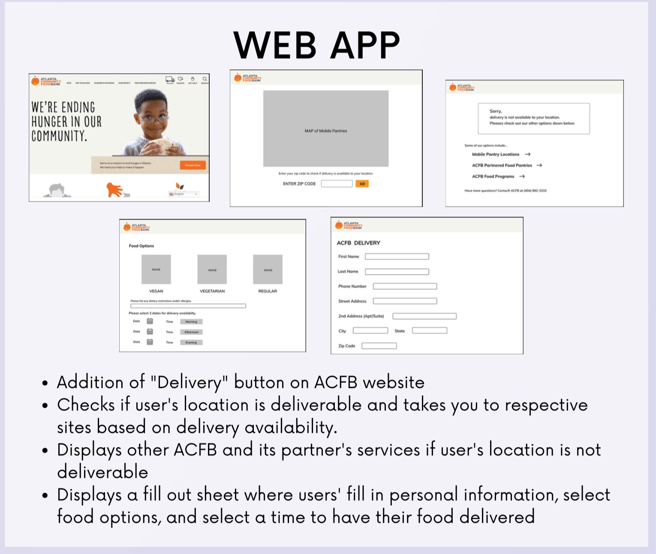
  + **Tim-** Prototype 2 - Flyer w/ Text Service
    - Our 2nd design alternative is an expansion of the ACFB texting service for users to sign up for the food delivery service and keep track of their delivery.
    - For this design alternative, we also began with a storyboard to depict what a user’s interaction may look like, then creating low fidelity prototypes of the flyer and iterating until we reached the final prototype
    - Read off poster
    - 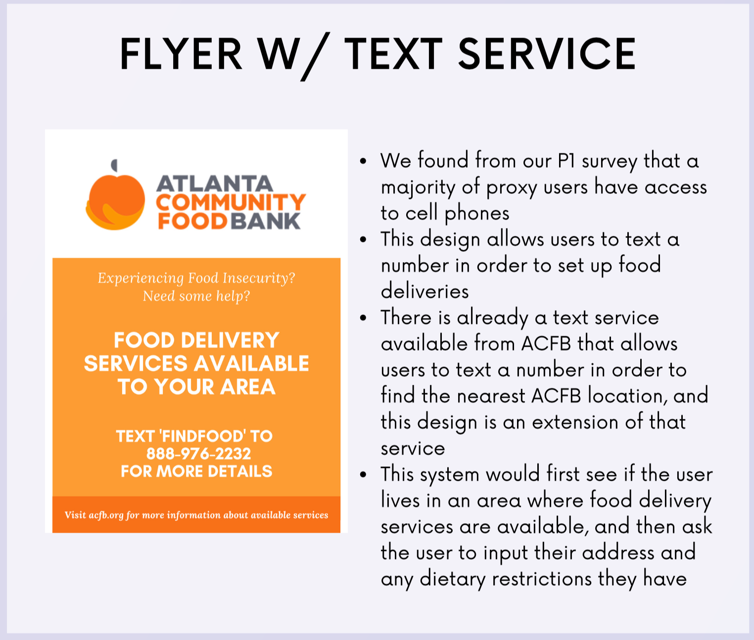
  + **Philena**- Prototype 3 - Mobile App
    - And our 3rd design alternative is the creation of a mobile application for users to sign up for the food delivery service and keep track of their delivery.
    - For this design alternative, once again, we used a storyboard to depict a user’s interaction with the mobile application. We then created a low fidelity vertical prototype on paper. We then used a card based prototype for each of the screens and iterated until the final mockup.
    - Read off poster
    - 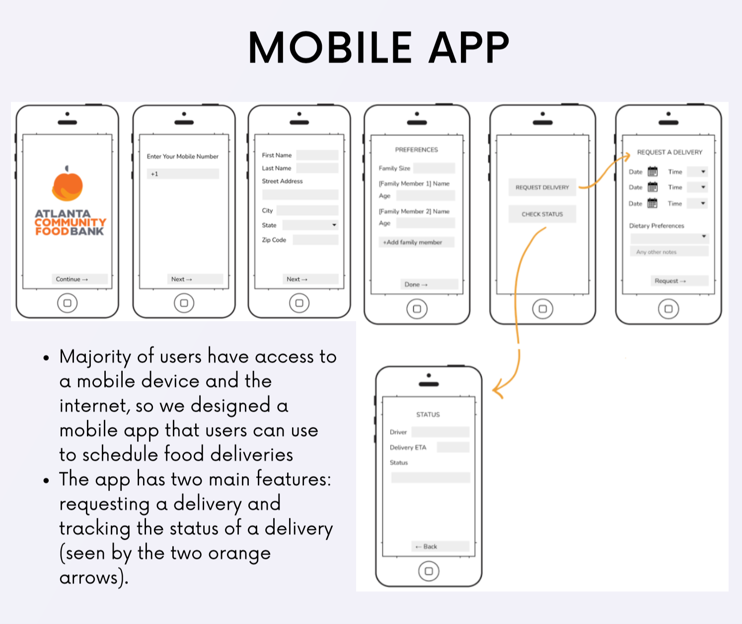
* **Evaluation & Criteria**
  + **Tim-** Our five group members each rated the designs using the eight criteria on a scale from 1-5, with 5 being the most effective. The ratings were averaged and summed for each design criteria, giving the design alternatives total score.
  + **Philena**- We added sustainability because it is important to measure how well the interface can be supported and maintained, especially in the future, as ACFB is a non-profit organization and is mainly supported through volunteers. Cost was added for this reason as well because if the system can’t be funded then our stakeholders will not benefit. Efficiency was also taken into account as a measure of how quickly and effectively users set up food deliveries with ACFB. Learnability is also a part of this process as a measure of how long it takes users to learn how to navigate the system.
  + **Tim-** Website: a richer interface, more information and feedback can be presented, however, there would be a higher learning curve, especially for those not familiar with technology
  + **Tim-** Texting service would be the most accessible as it doesn’t require Internet or smartphone access, but does not have a rich enough interface for useful information as it rated low in utility
  + **Tim-** Mobile app: richer interface but higher learning curve and lacks in sustainability as costs would be high and maintenance is needed for upkeep
* **Other Tips:**
  + Each member of the team should be articulate
  + EACH design reflects the richness of the TEAM aka not look as if one person was in charge of each design alternative